José Pinto Peixoto, geophysicist and meteorologist

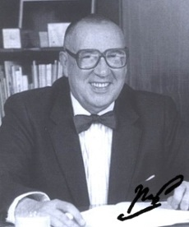
José Pinto Peixoto was one of the most prominent Portuguese geophysicists and meteorologists. His work highlights some of the first systematic studies of the global circulation in the atmosphere, and in particular of the global cycle of water in the atmosphere. He was born on November 9, 1922 and died on December 6, 1996.
He studied at the Liceu Gil Vicente in Lisbon and in 1944 he finished his degree in Mathematical Sciences at the Faculty of Sciences of the University of Lisbon. In 1945 he completed an internship at the Geophysical Institute Infante D. Luís, joining the newly created National Meteorological Service the following year.
Between 1946 and 1952, he studied Physics and Meteorology and in 1952 he finished his degree in Geophysical Sciences and was admitted to the Faculty of Sciences of the University of Lisbon. Nevertheless, he continued his activity in the National Meteorological Service where he gave lectures and courses and created the Division of Studies.
In 1954 he obtained a scholarship from the Lisbon Academy of Sciences to continue his research work at the Massachusetts Institute of Technology (MIT) in the United States. There, he joined the research group of Prof. Victor Starr, who was responsible for the first systematic studies of the global circulation of the atmosphere that included recognized scientists in which they stood out, besides Pinto Peixoto, Edward Lorenz, Barry Saltzman and Abraham Oort.
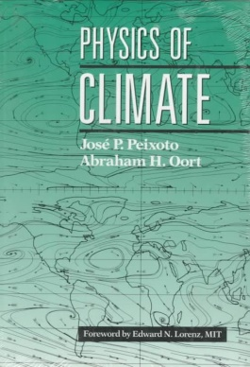
After returning to Portugal in 1956, he maintained a close collaboration with the MIT team and other research centers in the US, where he spent several seasons. In 1958, in the International Geophysical Year, the current system of continuous observation was created, which generated a large amount of data at a global level. Pinto Peixoto made the study of the water cycle on a global scale, producing the first maps of global transport of water by atmospheric circulation. In the 1960s and 1970s he participated in the development of the current models of global circulation used in the meteorological forecast.
Between 1969 and 1973 he was vice-rector of the University of Lisbon and director of the Geophysical Institute in 1970. He also helped create the universities of Beira Interior and Nova de Lisboa. He was president of the Science class at the Lisbon Academy of Sciences between 1980 and 1996.
In 1980 he began a synthesis of his research work in collaboration with Oort. This synthesis led to the book "Physics of Climate", published in 1992 - a reference work in this field.
Pinto Peixoto also published several books on climate and environmental issues. On 11 March 1993 he was awarded the Grand Cross of the Military Order of Sant'Iago da Espada. He left more than 50 published research articles. A statue was erected in front of the Faculty of Sciences of the University of Lisbon.
Gonçalo Oliveira and José Henrique, 7º1

