Elvira Fortunato, scientist, researcher and professor

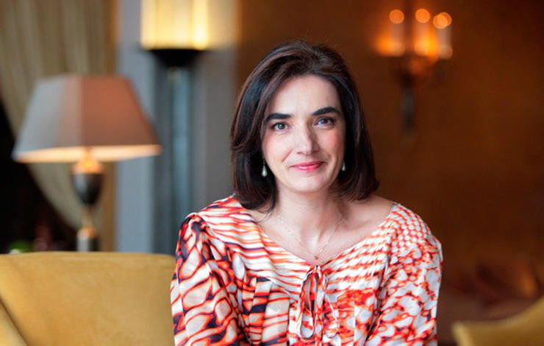
Elvira Maria Correia Fortunato is a Portuguese scientist, researcher and professor. She is a pioneer worldwide in electronic paper, namely in transistors, memories, batteries, screens, antennas and solar cells. She is currently vice-rector of Universidade Nova de Lisboa. She was born in Almada, Setúbal, on July 22, 1964 (54 years old). She is a scientist, researcher at the Faculty of Science and Technology of the New University of Lisbon and a Portuguese professor.
Graduated in Materials Engineering at the Faculty of Science and Technology of the New University of Lisbon. He did his doctorate in the field of Microelectronics and Optoelectronics, guided by Rodrigo Martins, in 1985.
The research team of the Materials Research Center (CENIMAT) led by Elvira Fortunato and Rodrigo Martins was distinguished for the discovery of the transistor paper.
On June 8, 2010, she was awarded the rank of Grand Officer of the Order of Prince Henry the Navigator.
Elvira Fortunato has been a member of the Council of National Orders since June 9, 2016 and is Deputy-Dean of the NOVA University of Lisbon since September 14, 2017.
She is married since 1986 to the researcher Rodrigo Martins, one of the inventors of electronic paper. He was her doctoral advisor. They have a daughter in common.
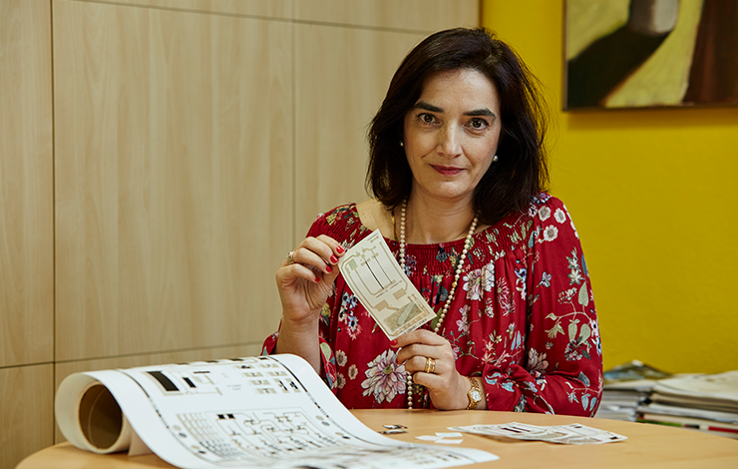
This scientist has won several awards, such as the Femina Prize for merit in science in 2010, the 2012 Prize for Research City of Almada, in 2016 the Blaise Pascal Medal and the Czochralski Medal in 2017.

