PORTUGUESE SCIENTISTS
António Egas Moniz
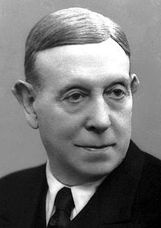
Portuguese neurosurgeon awarded with the Nobel Prize (1949).

António Caetano de Abreu Freire Egas Moniz born António Caetano de Abreu Freire de Resende, popularly known as António Egas Moniz, was born in Avanca, Estarreja, on November 29, 1874 and died in São Sebastião da Pedreira, Lisbon, on December 13, 1955.
He was a doctor, neurosurgeon, researcher, teacher, politician and Portuguese writer.
He was responsible for the development of arteriography, or cerebral angiography in 1927, a discovery that revolutionized medicine and neurosurgery, allowing the diagnosis of brain tumors and the diagnosis and treatment of cerebral aneurysm and AVM (arteriovenous malformation). He was nominated three times for the Nobel Prize for this discovery (1928, 1929, 1930). Inventor of the neurosurgical procedure called prefrontal leukotomy. By this last discovery was awarded with the Nobel of Physiology or Medicine in 1949, shared with the Swiss physiologist Walter Rudolf Hess.
Projeto ON THE EDGE

Heitor Pinho 7º5

