António Damásio, neuroscientist
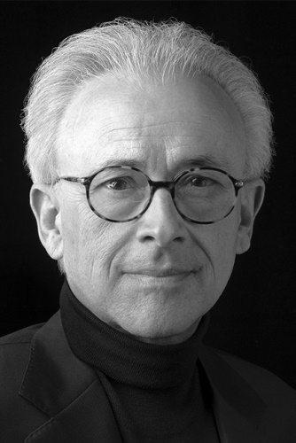
Who is António Damásio?
António Rosa Damásio, born on February 25, 1944 in Lisbon, is a Portuguese neuroscientist who works on the study of the brain and human emotions.
He's a professor of neuroscience. He has written several books that talk about human emotions.

His career
-He graduated in medicine from the Faculty of Medicine of the University of Lisbon in 1969, where he also received his doctorate in 1974.
"He later moved to the United States as a researcher at the Boston Aphasia Research Center.
-He worked as a clinician in the treatment of behavioral disorders and cognition. As a theorist he became interested in neurobiology of the mind, especially studying neural systems related to consciousness.
He is currently a member of the Department of Neurology at the University of Iowa, where he is a researcher and a science book writer.

Some of his books
- The Strange Order of Things
- The Feeling of Yes
- To the Meeting of Spinoza
- The Book of Consciousness

Some of his prizes
- Richard Wollheim, London, UK
- Principal Prince of Asturias for Scientific and Technical Research
- Reenpää Award, Finland
- Golden Brain Award
- Grade Grawemeyer in the area of ​​Psychology
- Freud Mediator in the area of ​​the neurobiology of the mind
Rodrigo Alves, 7º1 02/09/2019

