From the chart we can see that primary energy consumption in Croatia, expressed in million tonnes of oil and oil equivalent (TOE), has been more or less dropping since 2008, and is still well below our target of 11.15 TOE by 72,65%.
By "Primary Energy Consumption" is meant the Gross Inland Consumption excluding all non-energy use of energy carriers (e.g. natural gas used not for combustion but for producing chemicals). This quantity is relevant for measuring the true energy consumption and for comparing it to the Europe 2020.
Our good trend is unfortunately not because of high energy efficiency in consumption, but because of general underdevelopment.

Total energy consumption in Croatia increased at an average annual rate of 0.1% in the period 2000 - 2007. The fastest growth in emissions was recorded in the period from 2000 – 2007, when the growth rate of the total energy consumption was 3.1%. After 2008 total GHG emissions decreased at an annual rate of 2.4%.

Very fast growth was recorded in wind electricity and in solar and geothermal heat consumption in the period after 2008. Heat and coal and coke had significantly lower shares in the final energy consumption which then caused a drop in GHG emissions.

An increace of 20% in energy efficiency is one of our targets by 2020 by introducing eco-friendly technologies such as biogas and wind and solar turbines.

In the charts above, we can see that from 2010- 2012, the largest share in domestic energy consumption moved from energy and transport sector to household and services sector. The reason can be the crysis in production sectors. A drastic increase in household and services sector share in total energy consumption could be a result of main economy focus in Croatia shifting more towards tourism.

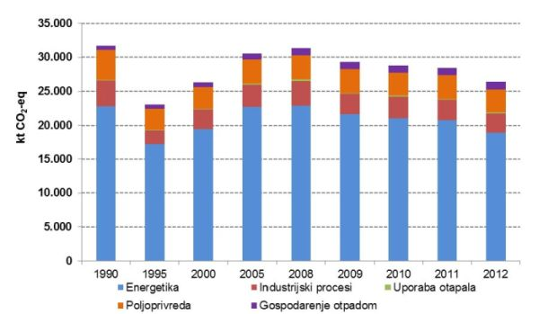
Kilotons of greenhouse gasses emissions from 1990-2012 by sector

In the chart above we can see that the inhabitants of Croatia from year 1990 to 2013 used fossil fuels as primary energy sources because of high share of GHG emissions from energy sector. In the beginning coal wasn't really used, but its usage has slightly increased in 2008 along with hydro efficiency.

From the chart we can see a drastic change in GHG emissions from 1990 to 1995 because of the war in the Balkans. After that period an increase in emissions is visibile due to recovery of the general economy. Following the global economic crisis the chart shows a slight drop of GHG emissions, probably due to destabilisation of industry and energy sector.

Most of the GHG emissions come from the energy sector, but that trend is dropping, hopefully because of new technologies that are more energy efficient and eco-friendly. Low shares of industrial and agricultural GHG emissions point to underdevelopment of the said sectors, but it would be great to keep them that low due to responsible managment. The trend should follow the general trend of greenhouse gas emissions by sector in EU-countries as shown below.
