Statistics on Europe 2020

My topic: Employment in Finland 2008-2016 charts
Amanda Soini 9A

Introduction

Employment has played an important part throughout Finland’s history. The first employees in Finland worked with agriculture and manufacturing. Nowadays, Finland is known to be one of the world’s most technologically advanced countries.
As Finland is a quite conservative nation, it can be hard for immigrants and people who move to Finland from abroad to get work careers. Finland is in a need to get more people from abroad to work in, for example, the Finnish medical and healthcare sectors. This shall happen during the upcoming years to further develop the medical sectors in Finland.

I will be comparing how employment has changed in Finland between the years 2008-2016. I will do this by looking at different charts that show the number of employed people in two different age groups.

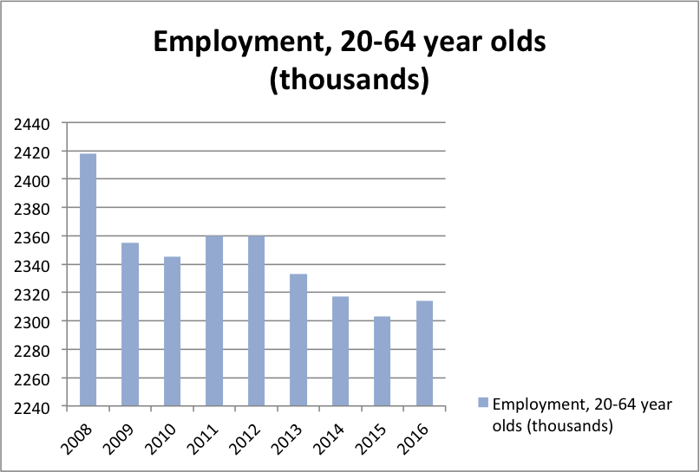

Employment among 20-64 year olds
As seen in the graph, there has been a drastic drop in employment after year 2008. Between years 2011-2012 the amount of employed people increased. However, since 2013 the amount has mostly decreased until 2016, when there was a small increase in employment again.

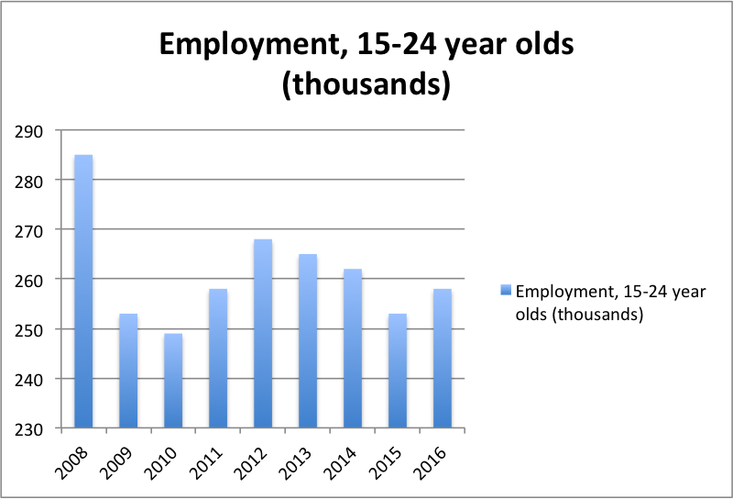

Employment among 15-24 year olds
Between years 2008-2010, there has been an even bigger drop in employment in this age group, when comparing to the older age groups’ statistics. According to this graph, the amount of employed people has decreased by over 30 000 people in just one year (2008-2009). By 2012, the amount had increased little by little, and then decreased again in 2013. Despite this fact, the amount of employed people still managed to increase to an amount of almost 260 000 people in 2016.

When comparing these two age groups, I have come to notice that the change of employed people is more drastic in the younger age group than in the older age group. There can be many factors that might have lead to this result. On reason to why the amount of younger employees decreased in 2009 could be that many want more education and aim to continue their studies. Many find working at the age of 15-24 to be hard, due to little experience. Therefore, continuing your studies at a university or college might be a better option than working at such a young age.

Looking at the GDP chart of the same period (chart below) gives also some explanation to the drop in employment after 2008.

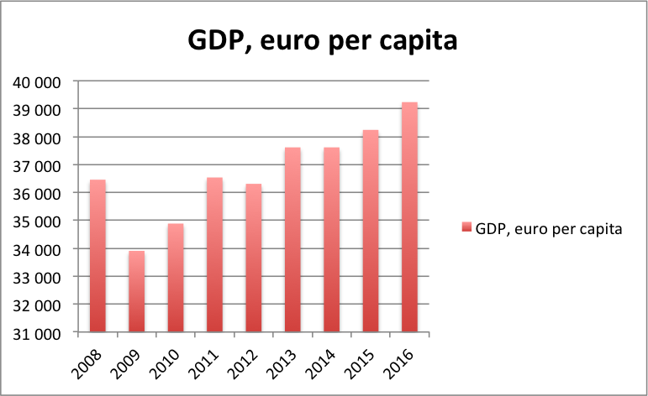

The GDP dropped dramatically in 2009 in Finland and this means that the number of jobs have most certainly also decreased as a cause of the drop in the economy. However, the GDP has slowly increased during the last years, even though the number of employed people have not increased in the same way. This tells that the GDP and employment figures do not go hand in hand at all times. Other reasons to why the employment rate has decreased during the recent years could be governmental unemployment aid, for instance. Also, there might be a gap between types of jobs and skills that are needed in them. Fortunately the employment trend seems to be going upwards in 2016.

Conclusion

The process of this investigation has helped me figure out reasons to why employment is like this in today’s society. The changes in employment can clearly be seen from the charts, and the eventual reasons to why this has occurred are analyzed. Overall, employment is a very interesting topic that Finland should work on even more in the future.

Sources:
https://www.prospects.ac.uk/jobs-and-work-experience/working-abroad/work-in-finland
https://finland.fi/facts-stats-and-info/how-about-getting-a-job-in-finland/

