Long-term unemployment rate of active population in Croatia

The long-term unemployment rate is the number of persons unemployed for 12 months or longer as a percentage of economically active population. The unemployment rate is the number of unemployed persons as a percentage of the total number of people employed and unemployed. Unemployed persons comprise persons aged 15 to 74 who fulfil all the three following conditions: are without work during the reference week; are available to start work within the next two weeks and have been actively seeking work in the past four weeks or have already found a job to start within the next three months. (Definition given on Eurostat)

One could come to the conclusion that Croatia has a really bad unemployment problem and could use fulfilling the Europe2020 objective in the field, which is for the unemployment of people aged 20-60 to be lower than 25% by 2020. However, Croatia already has the aspired unemployment rate goal. But still, it is almost common knowledge that we have a big unemployment problem. The reason the statistics are so perfect is because they do not portray everyday life in Croatia accurately, and have to be viewed alongside the emigration statistic.
The data source is the quarterly EU Labour Force Survey (EU LFS). The survey covers the resident population in private households.

Youth unemployment rate by sex in Croatia
Year | Total % | Females % | Males %
2007 | 25,4 | 29,2 | 22,6
2008 | 23,6 | 28 | 20,7
2009 | 25,4 | 27,8 | 23,8
2010 | 32,3 | 33,1 | 31,8
2011 | 36,6 | 36,3 | 36,7
2012 | 42,2 | 42,2 | 42,2
2013 | 49,9 | 50,4 | 49,5
2014 | 44,9 | 45,5 | 44,5
2015 | 43,3 | 43,5 | 41,5
2016 | 31,8 | 32,2 | 31,4

The youth unemployment rate is calculated by dividing the number of unemployed persons aged 15 to 24 by the total active population of the same age group. The indicator is based on the EU Labour Force Survey.

Simmilar to long-term unemployment rate, the youth unemployment rate seems to follow a good trend, but again, we lost a large percentage of young economically active population in many emigration waves that hit Croatia since joining the EU.
For example, the explanation behind the dropping unemployment rate is simple – it is a logical step following the increased number of people emigrating from Croatia.
Furthermore, there are a lot of unregistered employees that haven't been taken into count. Which means that yes, people are employed, but within the shadow economy market, or within the same fields that aren't prosperous to the country's economy.
One factor that also helps falsify the statistics unintentionally is that our annual rate of unemployment changes drastically when comparing the summer months to other times of the year. That is, because in the summer we have seasonal workers seemingly lowering our unemployment rate.
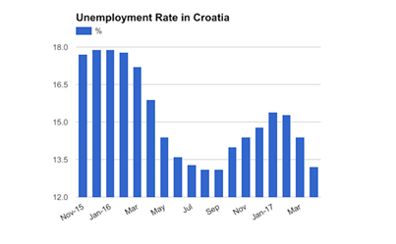

The conclusion is that Croatia needs to think beyond the set objectives, as it also has a deeper problem. In the future, our objective should be to lower the youth unemployment rate which is currently around 40% and, to manage fulfilling that, it is crucial that we keep young people from immigrating at this rate.

