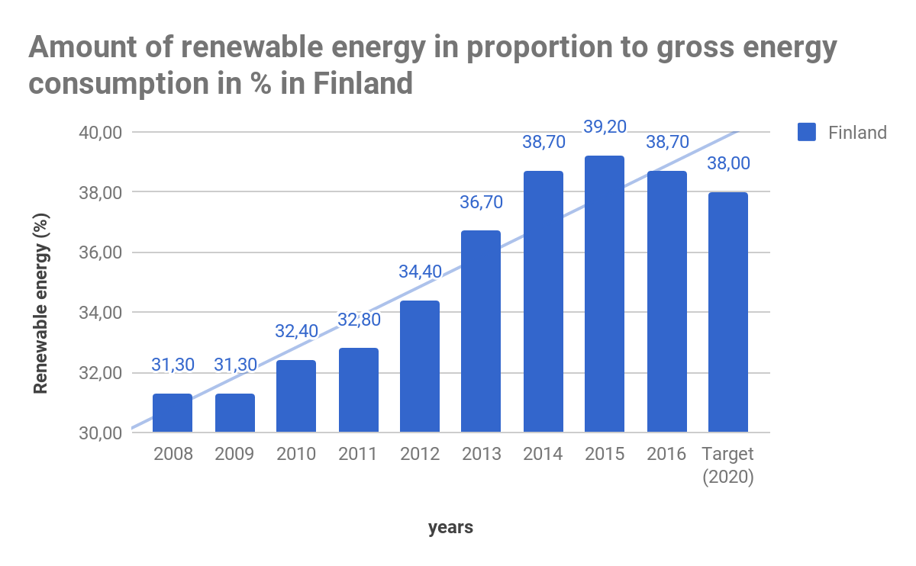
The trendline is pointing upwards, wich means we are going in the right direction. At the moment we are over the target of renewable energy for 2020, so if we keep it going we will probably meet Europe’s expectations, which is good.
This might be because renewable energy has gotten more usual and popular because of that people care more about the world, and how it will look like in the future, and that has lead to it getting cheaper.
Finland’s economy has also gotten better which has motivated more people to have the world to go in a positive direction.

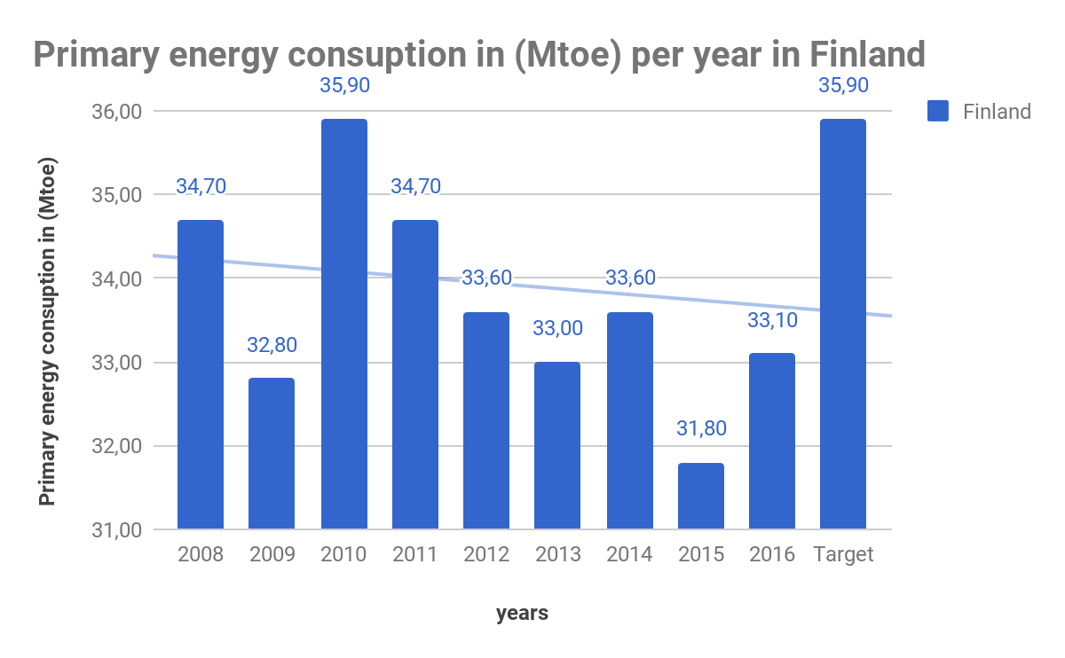
Mtoe=Million tonnes of oil equivalent

The trendline is going downwards, which means we are using less energy, and less of nature's resources , and that is good. We are under the target here as well and we have a good chance to continue to use less.
People saves more energy because they are more knowledgeable about the benefits of it.
The two drops in the energy consumption is when the economy worsened, which proves that we can perfectly survive without much energy, which also makes us wonder why we are using so much energy in the first place.

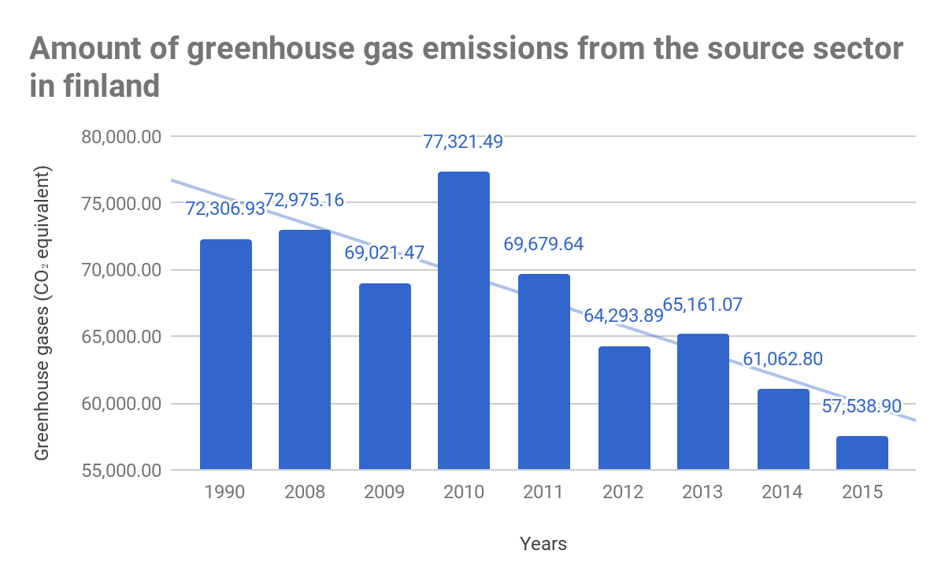
CO₂=koldioxid

The trendline is going downwards, and that’s also a good sign. This is probably also because people are more aware of things and we actually try to keep it down.
The reason of why they have gone up in 2010 and 2008 is because the economy was going better then and that means that we haven’t cared about greenhouse gases when our economy is good.

BNP FINLAND

