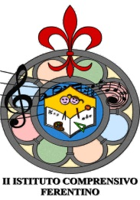 | MINISTERO DELL’ISTRUZIONE, DELL’UNIVERSITA’ E DELLA RICERCA  UFFICIO SCOLASTICO REGIONALE PER IL LAZIO  II ISTITUTO COMPRENSIVO  (Scuola Infanzia - Primaria- Secondaria 1° Grado)  Via A. BARTOLI, 53 - 03013 FERENTINO (FR) -  fax 0775.241093  fric84000g@istruzione.it - Posta Certificata: fric84000g@pec.istruzione.it  web: www.ic2ferentino.gov
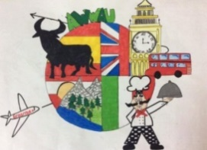

Prot. N. _______________ A WONDERFUL WORLD AROUND US
Del ___________________ 2015-1-ES01-KA219-016089
2nd TRANSNATIONAL MEETING PROGRAMME
ITALY
from 16th to 22th October 2016
15th Saturday
Austria Arrival
16th Sunday
Spain and UK Arrivals
17th Monday
Morning
8:30 / 11:00 School Visit -
11:30 / 12:30 Town City Hall
Afternoon
01:00 Lunch at School
02: 00 Guided tour of Ferentino and Diocesano Museum
18th Tuesday
Morning
9:00 Olympics Games
International teams Games ( Volleyball – Basket – Athletics)
Afternoon
01:00 Lunch at School
02:30 PowerPoint Presentations on traditional National Games with demonstrations
19th Wednesday
07:30 Trip to Rome Full Day
20th Thursday
Morning
09:00 – Trip to Fiuggi Golf Course and Baths
Afternoon
01:00 Lunch at school
02:00 Sport Labs - Biographies Games
05:30 Teachers meeting to revise the project
21th Friday
Morning
09:00 Trip to Anagni
Afternoon
01:00 Lunch at school
02:00 International teams Games Olympics Games prize-giving
08:00 Teachers dinner
22th Saturday
Departures.
Il referente del progetto Il Dirigente Scolastico
Prof.ssa Maura Fabrizio Prof. Salvatore Laino

