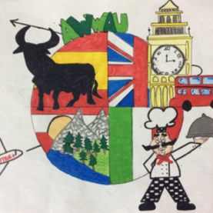
a wonderful world around us
2015-ka219-es01-016089

short-term exchanges of groups of pupils
guest teachers
the sports week
evaluation questionnaire
Write YES or NO next to the following statements:
Meetings with families have been done in order to tell about the trips. | Yes
There has been a process to choose the students taking part in the trips. | Yes
The students prepared a group presentation to be done in the host school. | Yes
Value from 0 (not at all), 1 (a little bit), 2 (sometimes), 3 (liked it), 4 (a lot) the following activities:
Welcome activity | 4
School visit | 3
Technology and science labs: mosaics, science experiment and presentations | 4
Tour around Ferentino | 4
Town hall visit and mayor’s welcome | 4
Sports: volleyball, athletics and basketball | 3
Traditional games: skip rope, spinning top, darts, etc. | 4
Presentations about traditional games | 3
Lunches at school | 2
Game on biographies | 4
Colosseum visit with guide in English | 3
Visit to Rome | 4
Trip to Fiuggi and baths | 4
Golf course | 4
Trip to Anagni | 4
Karate and Judo | 4
Prize giving ceremony | 4
Value from 0 (not at all), 1 (a little bit), 2 (sometimes), 3 (liked it), 4 (a lot) the following:
Selection of host families. | 4
Selection of host students. | 4
Communication with the host teachers. | 4
General impression of the programme. | 4
REFLEXION AND SUGGESTIONS FOR IMPROVEMENT
The activities are connected to the objectives and priorities of the project: use of new technologies, practice of second languages and learning of different cultures. The main theme of the week was music and most of the activities were related to this. We think the students really connected to one another and they enjoyed a lot all the activities but the meals at school. We also learnt from other school systems and ways of teaching languages.
Las actividades estaban conectadas con los objetivos y prioridades del proyecto: uso de las nuevas tecnologías, práctica de idiomas (enseñanza y aprendizaje) y aprendizaje de culturas diferentes. El principal tema de la semana, el deporte, estaba presente en la mayoría de las actividades. Pensamos que los estudiantes conectaron de verdad entre sí, y disfrutaron de todas las actividades (eso sí, no les gustó mucho las comidas en el centro). También hemos descubierto el sistema de diferentes centros escolares europeos y modos de aprendizaje – enseñanza de lenguas.

