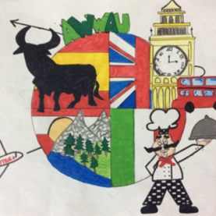
a wonderful world around us
2015-ka219-es01-016089

short-term exchanges of groups of pupils
families
THE week of sports
evaluation questionnaire

Write YES or NO next to the following statement:
We have attended meetings to learn about the project, the criteria to choose students involved and the activities to be done during the trips. | Y
Value from 0 (not at all), 1 (a little bit), 2 (all right), 3 (quite liked), 4 (loved it) the following statements:
I think my son/daughter has practiced the language during the trip and during the visit of the guest students. | Y
My son/daughter could contact us during the trip. | Y
Our guest could contact his/her family during his/her stay in our family home. | Y
We think this type of project improves the students learning process. | Y
Our son/daughter is more motivated now to learn second languages. | Y
We have been told about the activities to be done before, during and after the trip. | Y
We would recommend other families to participate in this project. | Y
SUGGESTIONS FOR IMPROVEMENT

