Brochures
February 2016

FEATURES
Description: We are going to create a travel guide about our town.

Project objectives:
- Know and vale the sociocultural aspects showing respect and tolerance.
- Improve competence in the second language in real communicative contexts.
- Use IT tools and other resources autonomously to look for, analyze, synthesize and present information.
- Transfer, learn and use quality teaching methods.
- Participate in individual and group decision taking.
- Foster artistic creativity.

Subject contents:
- First and second languages:
  - Description of places.
  - Giving directions.
- Art:
  - Creating, drawing or designing brochures with LucidPress.
  - Creating a map with Google Maps.
- IT:
  - Sketching and preparing brochures.

Timing: About six sessions.

MATERIALS

In order to do this project, you will need the following materials:
- Your notebook, ball-point pens and pencils to write.
- Your class booklet to practise.
- A laptop / tablet.
- Flash drive (in case you do not have a personal laptop or tablet).

TASKS

TASK 1 – Let’s design our brochures

  - Get in groups and have a look at these brochures teachers have prepared for you. What does a brochure include? Make a list with ideas (maybe a description of the town, a map, directions, pictures, telephones, etc.).

TASK 2 –Let’s organize the information!

DESCRIPTION OF THE PLACE
2.1. Find information about your town using different websites or the information you know. Write a short paragraph about it.

MAP AND DIRECTIONS
2.2. Have a look at Google Maps on www.google.com/maps
Create a map including the most important places of your town (some ideas: monuments, restaurants, parks, etc.).

PICTURES
2.3. In order to include pictures, you have two options:
- Use images from the web (without copyright):

http://recursostic.educacion.es/bancoimagenes/web/

- Use a camera and take your own pictures!

2.4. Describe those places seen in the pictures.

DESCRIPTION
#1 image
#2 image
#3 image
#4 image

EXTRA INFORMATION
2.5. If tourists want to go to a museum, for example, your brochure should also have its address, its telephone, its opening hours or its website. Find information about the most important places of your town.
 | #1 PLACE | #2 PLACE | #3 PLACE
Address
Opening hours
Website
Telephone

2.7. You may also include some extra information about other nearby towns.
TASK 3 –Let’s create our brochure
3.1. Organize the information you have found or written to create a real brochure in an open page, a diptych or a triptych. In order to create your brochure, you have some options:
- A manual brochure.
- A digital brochure, using:
  - Scribus
  - Open Office
  - www.lucidpress.com

3.2. All of them must include the following information:

- A WONDERFUL WORLD AROUND US
- 2015-1-ES01-KA219-016089

One of these paragraphs, depending on the language you use for them:

- This project has been funded with support of the European commission. This publication [communication] reflects the views only of the author, and the Commission cannot be held responsible for any use which can be made of the information contained therein.

- El presente proyecto ha sido financiado con el apoyo de la Comisión Europea. Esta publicación (comunicación) es responsabilidad exclusiva de su autor. La Comisión no es responsable del uso que pueda hacerse de la información aquí difundida.

- Dieses Projekt wurde mit Unterstützung der Europäischen Kommission finanziert. Die Verantwortung für den Inhalt dieser Veröffentlichung (Mitteilung) trägt allein der Verfasser; die Kommission haftet nicht für die weitere Verwendung der darin enthaltenen Angaben.

- Il presente progetto è finanziato con il sostegno della Commissione europea. L'autore è il solo responsabile di questa pubblicazione (comunicazione) e la Commissione declina ogni responsabilità sull'uso che potrà essere fatto delle informazioni in essa contenute.

- Ce projet a été financé avec le soutien de la Commission européenne. Cette publication (communication) n'engage que son auteur et la Commission n'est pas responsable de l'usage qui pourrait être fait des informations qui y sont contenues.

- The Erasmus + logo, the logo of the project and others if you want (your school, your town, etc.).

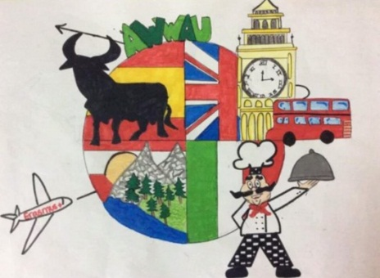

TASK 4 –Let’s present our brochures!
4.1. You are going to show your town to students from Austria, Spain, Italy and England.
- Print your brochures and give it to them!
- Tell them about your town.

