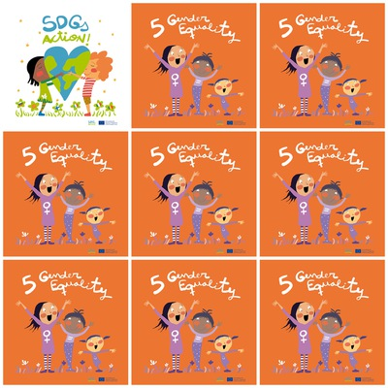

**women get the right to vote in France and Bulgaria in 1944.**

**Boys are not better in maths than girls.**

**Marie Curie , Anna Aslan were famous scientists.**

**Rosa Parks fought against apartheid in the USA.**

**5.Gender Equality**

**1. When did women get the right to vote in France and Bulgaria ?**

**2. Is it true that boys are better in maths than girls ?**

**3. Can you give the name of a famous scientist ?**

**4. Who was Rosa Parks ?**

**5. What is the color of the smallest girl's dress ?**

**6. How many characters are wearing dresses ?**