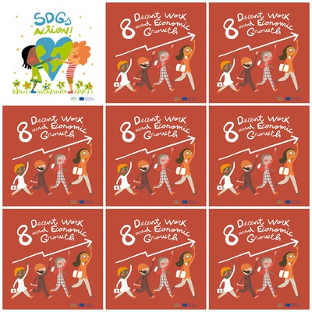w

Еmployment for young people.

Employment for people with disabilities.

Fair payment for workers.

Elimination of the worst forms of child labour.

**8. Decent Work and Economic Growth**

1. What do young people need?

2. What do people with disabilities need?

3. What has to be the payment for workers?

??

**???**

4. What do we have to eliminate?

5. What is the color of the shoes of the first person in the column in the logo?

6. What is the color of the pants of the first person in the column in the logo?