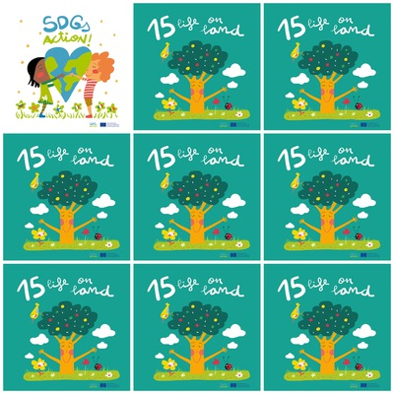

Don't buy a pet: we can adopt them at the kennel or pet shelter and Don't buy products if they are tested on the animals

Volunteer with an association /shelter that helps pets as well as endangered species

Clean your parks and forests and support the ecosystem of your local space by taking part in clean-up events.

Do not use pesticides because it is harmful to the earth and plants.

because it is harmful to the earth and plants. because it is harmful to the earth and plants.

**15. Life on land**

1. What colour are the apples on the tree of the Goal 15 logo?

2. What products can we avoid to buy?

3. What can you do to help parks and forests?

4. What can you do to help animals?

4. how many hectares of forest are lost in a year?

5. Why shouldn't we use pesticides?

6. Why do you have to participate in cleaning events?