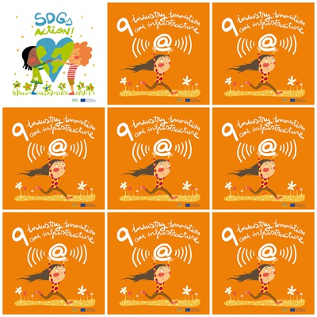

4 billion people do not have access to theInternet.

90 percent of the people are from the developing world.

20 million people can work in the renewable energy sectors by 2030.

Sustainable infrastructure and innovations everywhere!

**9. Industry, innovation and infrastructure**

1. How many people do not have access to Internet?

2. How many people are from the developing world?

3. How many people can work in the renewable energy sectors?

4. What do we need everywhere?

5. What is the symbol drawn above the child's head in the logo?

6. How many flowers are painted in the logo?