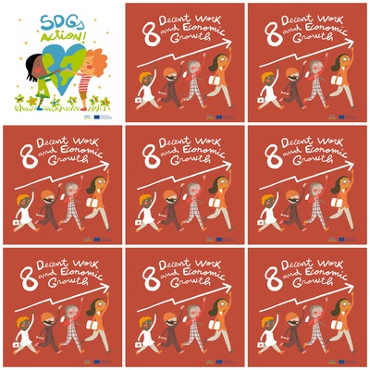w

700 million workers lived in extreme poverty in 2018.

600 million new jobs need to be created by 2030.

Protect labour rights and promote safe working environment**.**

Protect labour rights for migrant workers.

**8. Decent Work and Economic Growth**

**1**. How many workers lived in poverty in 2018?

**2.** How many jobs need to be created by 2030?

3. What do we have to protect for all workers?

4. What do we have to protect for migrant workers?

5. What is the color of the blouse of the last person in the logo?

**6. What does the first person in the column in the logo carry?**