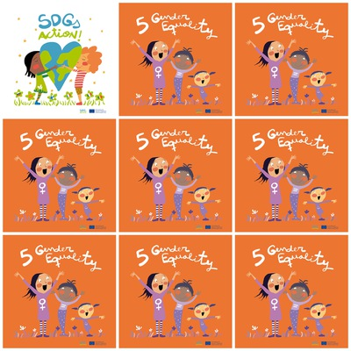

**women get the right to vote inCatalonia in 1931.**

**20% of wives are beaten by their husbands.**

**Estonia and Iceland have a woman as President.**

**Mother Teresa devoted her life to help poor children in India.**

**5.Gender Equality**

**1. When did women get the right to vote inCatalonia ?**

**2. how many wives are beaten by their husbands?**

**3. Can you give me the name of a country where there is a woman as President ?**

**4. Can you give the name of a woman who devoted her life to help Indian children ?**

**5. What is the color of the middle girl trousers ?**

**6. How many characters have blond hair ?**