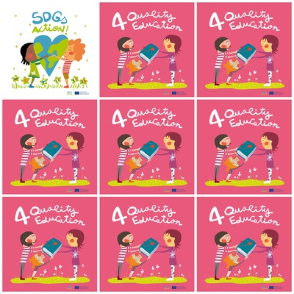

**There are 22% children out of school in Africa.**

**We should ask our governments to make education a priority.**

**In some countries, there are not enough teachers for quality education.**

**All schools should be connected to internet.**

**4. Quality Education**

**1. What is the percentage of out-of-school children in Africa ?**

**2. What should we ask to our governments ?**

**3. What is missing in some poor countries for quality education ?**

**4. Is it important to connect all schools to internet ?**

**5. What is the symbol of Quality Education ?**

**6. How many characters are there ?**