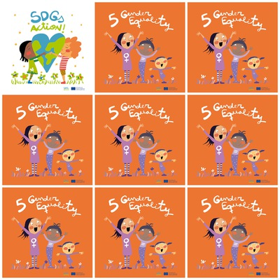

**women got the right to vote in Italy 1945.**

**750 millions girls got married before the age of 18**

* 2

**Only 23% women are elected in parliaments.**

**Malala Yousafzai is a pakistanese women who got the Nobel prize for Peace.**

**5.Gender Equality**

**1. When did women get the right to vote in Italy ?**

**2. How many girls got married before the age of 18 ?**

**3. What percentage of women are elected in parliaments ?**

**4. Do you know a pakistanese women wo got the Nobel prize for peace ?**

**5. what are the colours of the characters clothes ?**

**6. How many characters are there ?**