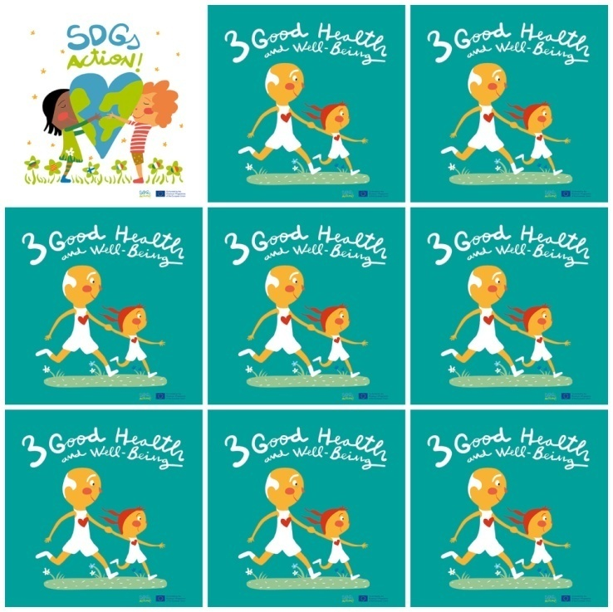

Millions of people have no access to soap and water to block the spread of diseases.

Make sure that you and your family are vaccinated to prevent diseases.

Each year US$1 billion is spent on vaccines which can save up to 1 million children.

By 2030, we have to reduce the number of deaths and illnesses from hazardous chemicals and air, water and soil pollution.

**3. Good Health and well-Being**

**1.** What material stops spreading diseases?

**2.** What can you do to prevent diseases?

**3.** How much money is spent each year on vaccines?

**4.** When do the SDGs pretend to reach the 17 goals?

**5.** What is the color of the background?

**6.** Is there a house in the logo?