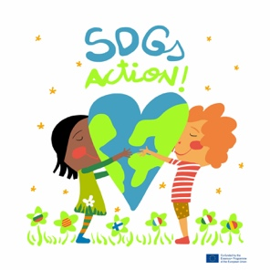
Online meeting 20th November 2020

AGREEMENTS

- Renewed website. Thank you Natasha for your great work on our project’s website .Photos how students work together, not only the results.
- Applying for school labels:
eTwinning school : France, Italy, Finland . Bulgaria has already sent the renewal of eTwinning school label.
UNESCO school: France, Catalonia, Bulgaria Italy, Romania. 3.
- Climate Action Project evaluation:
France: Causes and effects easy to look at . Communicating with other people of the word was interesting but the level of English was quite difficult. Green week was fun because all the school participation made it more relevant.
Finland: different classes were involved, students were so eager on that. They combined different things and skills, applications, group work. Good way of talking and make research .
Bulgaria: The activities payed good attention about the Climate change. Also problems with the language, which made not possible to conversate with other countries from the world. GREEN WEEK very nice, maybe for the next activity we should cooperate a little bit more. Example. A country puts an issue and the other schools interact. Do it in a chain way. Create something together where the partners can contribute. More interaction with our students: mailing , online meetings.
Mid report from Bulgaria, very great ideas, but more collaborative work would be nice.
Italy: students received different discussions with experts from local area and they decided to write a manifesto for the municipalities of the area and they will interview them, and present the results of the project. Local TV and press.
Romania: online school, very nice and motivated students during the green week. Newspaper about this week. Climate change they attended the seminar with Jane Goodall.
Silvia will upload a short video about Jane G in the Climate Action pages
- SDGs peace: "peace in the world please", the wall of wisdom, went well. November task: Celebrities interactive map and in January we will do pair countries interviews: Italy- Catalonia , Bulgaria- France, Romania- Finland
- SDGs presentations: be ready at the end of December.
Safety internet rules: parents permissions only for Twinspace in Finland.
Raija will revise the Twinspace pages and made them private in case there is some content with no Finnish parent’s permission.
- EWWR'20: collaborative document ( Week 23rd-27th November) and then fill in the board game. Deadline: first week of December. Remember to take photos demonstrating how students are working and then playing with the game.
- Christmas time: online workshop meeting to make something together: Xmas card, Xmas gift, as a surprise, just get the material ready for the meeting and made with recycled material. 14th December at 9:00 CET all countries together.
- Zero hunger advertisement: forum and record a single video together joining all the actions ( each country proposes a simple action to reduce hunger in the world) Deadline: end December.
- Next meeting : Friday 15th January

Many thanks for all you collaboration, patience and enthusiasm

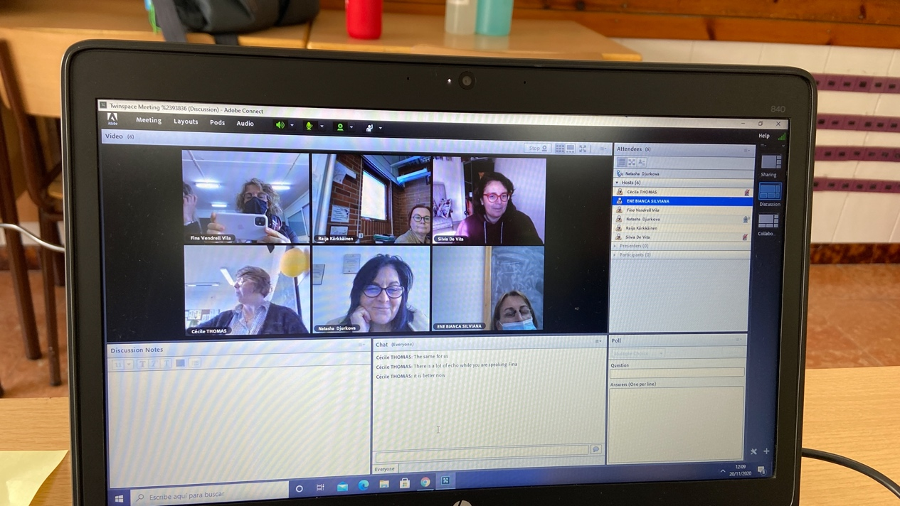

Take care and stay healthy

