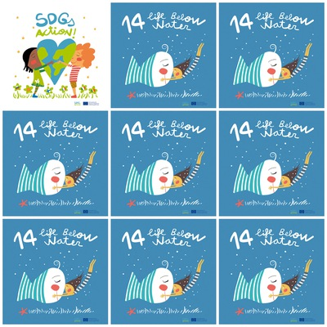

1. Oceans are the source of life of the planet and the global climate system regulator.

2. Oceans are the world’s largest ecosystem.

3. Oceans are home to nearly a million known species.

4. Oceans cover more than two-thirds of the earth’s surface.

**14. Life Below Water**

**1.** Which are the sources of life of the planet?

**2.**. What is the largest ecosystem in the world?

**3.** Which are home to a million known species?

**4.** How much do the oceans cover of the earth's surface?

**6.** How many drops are there in the picture?

**5.** In which country is the logo picture made?