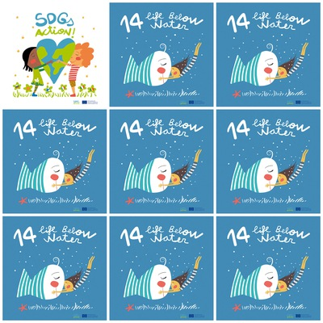

1. “Sustainable fisheries” means leaving enough fish in the ocean while also respecting habitats and ensuring people who depend on fishing can maintain their livelihoods.

2. Fisheries sustain millions of jobs and often pass down traditions and knowledge from generation to generation.

3.The targets of the goal 14 are to increase scientific knowledge, research and technology for ocean health.

4. We should support small scale fishers; implement and enforce international sea law.

**14. Life Below Water**

**1.**What do sustainable fisheries mean?

**2.**What do fisheries sustain?

**3.**Name one of the targets of the goal 14.

**4.**Should we support small scale fisheries or big scale fisheries?

5. How many organisms are there on thelogo?

5. How many organisms are there in the picture?

5. How many organisms are there in the picture?

**6.** What is not logical on the fish outlook?