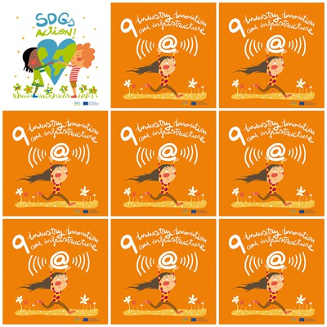

Cross-border cooperation and improvement of small businesses will bring industrial development.

About 2.6 billion people in the developing world are facing difficulties in accessing electricity full time.

2.5 billion people worldwide lack access to basic sanitation.

800 million people lack access to water.

**9. Industry, innovation and infrastructure**

1. What will bring industrial development?

2. How many people do not have access to electricity full time?

3. How many people do not have access to sanitation?

4. How many people do not have access to water?

5. What is the color of the flowers in the logo?

6. What is drawn on the logo: a boy or a girl?