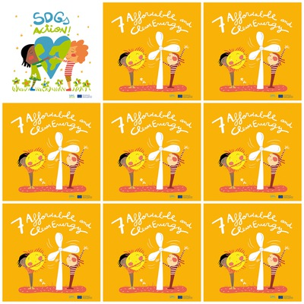

**A hydroelectric dam provides renewable energy**

**Wind turbines produce renewable energy but are noisy.**

**An agro-fuel is fuel made from plants.**

**Petroleum is not renewable but it is the most used energy source in the world.**

**7. Affordable and Clean Energy**

**1. Does a hydroelectric dam provide renewable energy?**

**2. What is the main disadvantage of wind turbines?**

**3. What is an agro-fuel ?**

**4. What is the most used energy in the world?**

**5. What does represent the white object ?**

**6. What is the character on the left carrying in his arms ?**