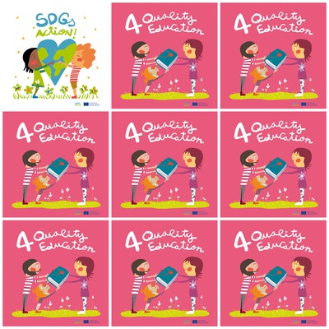

**617 millions of pupils in the world do not know well maths and reading.**

**Education reduces inequalities.**

**In Asia there are 6% children out of school.**

**Girls who do not go to school do not find a job.**

**4. Quality Education**

**1. How many pupils in the world do not know enough maths and reading ?**

**2. Does education reduce inequalities ?**

**3. What is the percentage of out-of-school children in Asia?**

**4. What happens to girls who do not go to school ?**

**5. How do the characters feel when exchanging the book?**

**6. What is the colour of the book ?**