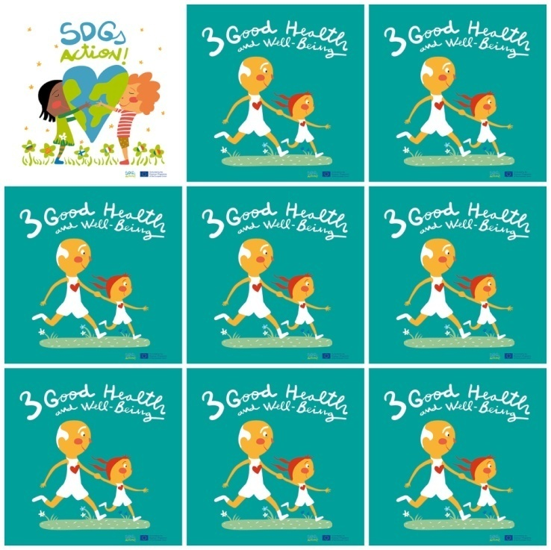

1.6 million children die before they reach 5 years of age.

Hygyiene,food and water are essential to have good health.

In poor countries people die because of lack of hospitals and doctors.

77.3 million people have become infected with HIV since the start of the epidemic.

**3. Good Health and well-Being**

**1.** How many children die before they reach 5 years old?

**2.** Say three essential elements to have good health.

**3.** Why do people die in poor countries?

**4.** How many people are infected with HIV?

**5.** What is the shape of the earth that children are holding?

**6.** What is the color of the girl's T-shirt?