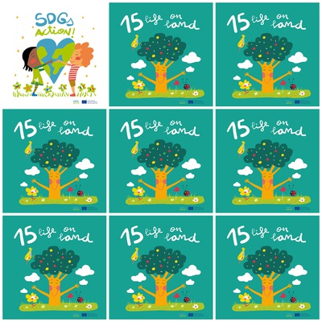

Agriculture is an important resource for human life but also offers a possibility of economic gain

Plant life provides 80 percent of the human diet

Forests cover 30 percent of the earth's surface and provide vital habitats for millions of species but 13 million hectares of forest are lost every year.

Nearly 7.000 species of animals and plants have been illegally traded.

**15. Life on land**

1. What is agriculture ?

2. In what percentage plant life is present in human diet?

3. What percentage of the land surface do forests cover?

4. How many hectares of forest are lost in a year?

4. how many hectares of forest are lost in a year?

5. how many clouds are there in the Goal 15 logo?

6. What does wildlife trafficking provoke?