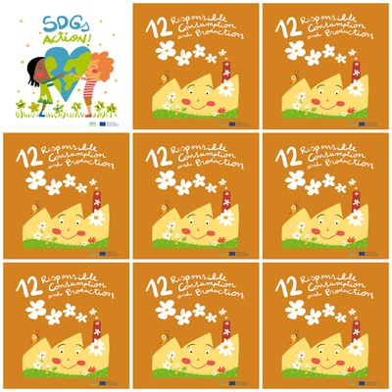

People waste too much food, water, energy and clothes.

Only 3% of our world’s water is drinkable and we are using it too fast.

A healthy nature is necessary for plants, animals and humans.

Coffee is the best known Fair Trade product.

In Finland there  are over 1200 different Fair Trade products on sale.

**12. Responsible Consumption and Production**

**1.** Say three things people waste too much.

**2.** What % of drinking water do we have on our planet?

**3.** Say 3 things healthy nature is important for.

**4.** How many fair trade products are there in Finland?

**5.**  Which animal is on the roof of the factory?

**6.** How many flowers are there in the chimney?