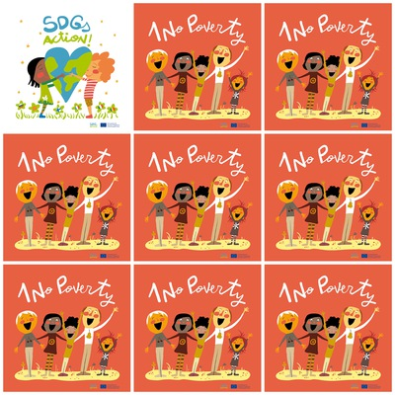

736 million people still lived on $1.90 a day.

Women are more likely to be poor than men.

**Half the people living in poverty are under 18.**

**15 countries eliminated extreme poverty by 2015.**

1. **No Poverty**

**1. How many people live on $1.90 a day?**

**2. Who is more likely to be poor – women or men?**

**3. How old are half the people who are poor?**

**4. How many countries eliminated extreme** p**overty?**

**5. How many people are painted on the logo?**

**6. What is the color of the logo?**