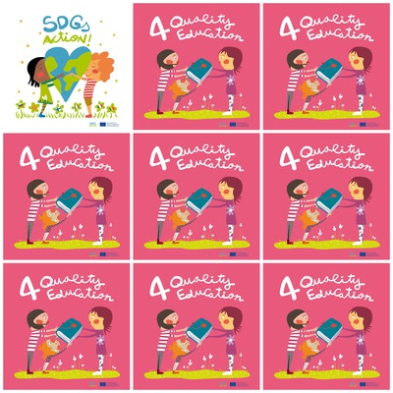

**57 millions children cannot go to primary school in the world.**

**In some countries, girls do not go to school because they must work at home.**

**In some countries there is not enough money to build schools.**

**In many countries, the schools are not adapted for disabled children.**

**4. Quality Education**

**1. How many students cannot go to primary school in the world ?**

**2. Why do girls do not go to school in some countries ?**

**3. Are there schools everywhere ?**

**4. Is it always possible to go to school for disabled children ?**

**5. What does the girl with flowerish pullover take in her hands ?**

**6. What colour is the book ?**