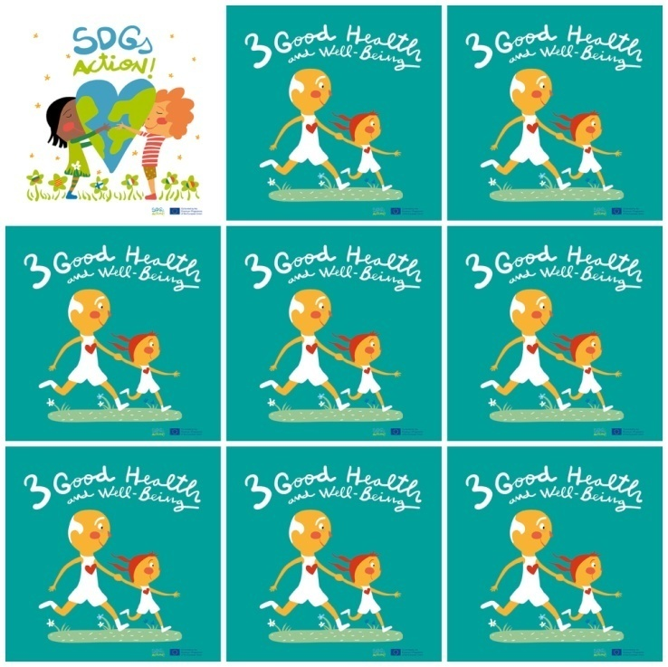

Only half of women in developing regions receive the recommended amount of health care they need.

Do not throw food away. Give it to those who need it, like animals.

At least half the world’s population are still with- out access to essential health services.

Kids are living injustices.  One in three can not go to school.

**3. Good Health and well-Being**

**1.** Do all women have the health care they need?

**2.** What can you do with the food that is left over?

**3.** How many people in the world are still without health services?

**4.** How many kids cannot go to school?

**5.** What is the color of the  girl’s shoes in SDG 3?

**6.** What number is the SDG of good health and well being?