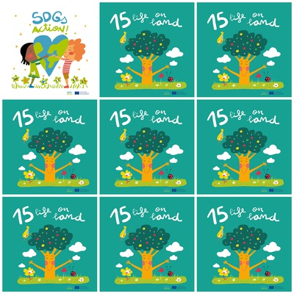

Wildlife trafficking not only erodes biodiversity, but creates insecurity and feeds corruption.

It is necessary to take action to reduce the loss of natural habitats because it is part of our common heritage.

1,6 billion people depend on forests and 2,6 billion people depend on agriculture

Forests are important because more than 80% of animals, plants and insects live on them

**15. Life on land**

1. What can we do to reduce the loss of natural habitats?

2. What insect is there on the grass?

3. How many people depend on forests?

4. Why are forests important?

4. how many hectares of forest are lost in a year?

5. How many people depend on agriculture?

6. Who are forests home for?