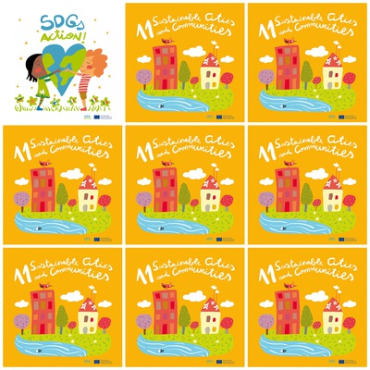

**11. Sustainable cities and Communities**

**1.**

**2.**

**3.**

**4.**

**5.**

**6.**