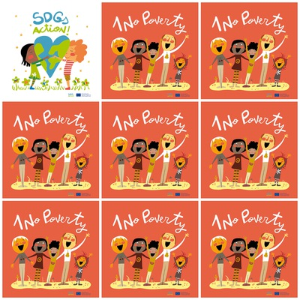

End poverty in all its forms everywhere**.**

The majority of people living on less than $1.90 a day are in sub-Saharan Africa

**One out of five children live in extreme poverty.**

**4 billion people did not benefit from any form of social protection in 2016.**

1. **No Poverty**

**1. Where the poverty has to end?**

**2. Where the majority of the poorest people live?**

**3. One of how many children live in extreme poverty?**

**4. How many people did not have social protection in 2016?**

**5**. **Where does the smallest person in the line of the logo stand?**

**6. How many people in the logo have black hair?**