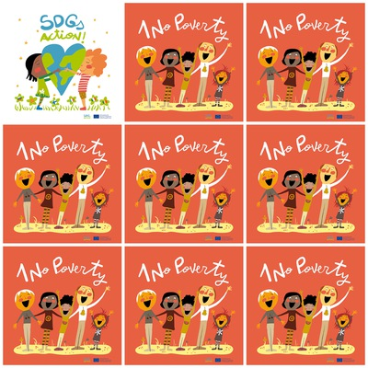

Increasing access to education is one way to reduce poverty.

Improving food security and access to clean water is a way to reduce poverty.

**Ending wars and conflicts can reduce poverty.**

**No war means more money to be directed to public services.**

1. **No Poverty**

**1. What can access to education reduce?**

**2. What can security of food and access to clean water reduce?**

**3. What can ending wars and conflicts reduce?**

**4. What does no war mean?**

**5**. **What color is the hair of the first person in the line in the logo?**

**6. What is the color of the shoes of the third person in the line in the logo?**