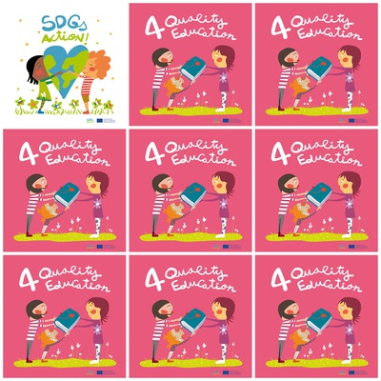

**Many schools should be built in Africa.**

**Books are not compulsory for quality education. You can use technology instead.**

**Teachers should follow training sessions.**

**It is important to go to school to be educated and to get a good job.**

**4. Quality Education**

**1. In which continent will we need to build the most schools?**

**2. Is it compulsory to have books for a quality education?**

**3. Do teachers need to be trained?**

**4. Why is it important to go to school ?**

**5. What is the colour of SDG4 (background) ?**

**6. How many girls are ther ?**