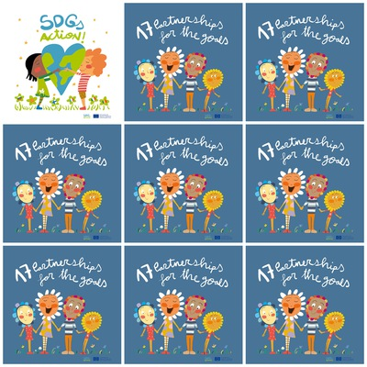

**17. Partenrship for the Goals**

**1.**

**2.**

**3.**

**4.**

**5.**

**6.**