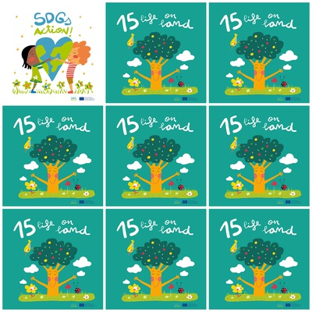

It’s vital to conserve and restore terrestrial ecosystems.

We must stop deforestation, desertification and restore degraded lands

We can reduce the use of paper, glass, plastic, metal and old electronics and later we can recycle them.

If we want to reduce the use of paper we can use electronic devices.

**15. Life on land**

1. what can we do before recycling waste?

2. What is it important to do with ecosystems?

3. How many bird can you see in the Goal15 logo?

4. What’s important to stop?

4. how many hectares of forest are lost in a year?

5. What can I recycle?

6. How can you reduce the use of paper?