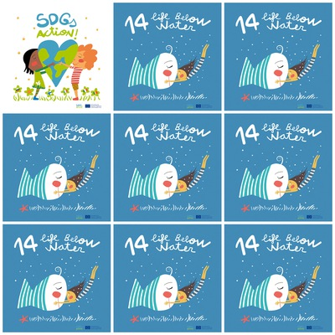

1. The official wording of the goal 14 is to "Conserve and sustainably use the oceans, seas and marine resources for sustainable development.”

2. The Goal 14 has ten targets to be achieved by the year 2030.

3. Ocean acidification is the ongoing decrease in the pH used by the uptake of carbon dioxide (CO2) from the atmosphere.

4. The main cause of ocean acidification is the burning of fossil fuels.

**14. Life Below Water**

**1.**What is the official wording of the goal 14?

**2.** How many targets has the goal 14?

**3.** What does cause ocean acidification?

**4.** What is the main cause of ocean acidification?

**5.** Why are the eyes of the fish closed?

**6.** How many colours can you find on the logo?