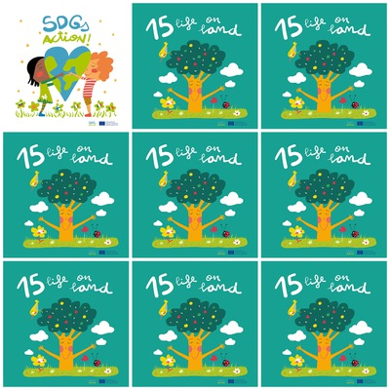

Mountain provide around 60 to 80% of water and nature-based climate solution can reduce co2 by 1 third

We must ensure conservation of the mountain ecosystem and prevent pollution of fresh water.

We must stop the hunting of animals of protected species because one day they will become extinct and their disappearance will damage the ecosystem.

Moving animals from their natural habitat to a different one can damage the ecosystem and Governments should make laws to protect the ecosystem

**15. Life on land**

1. How much can nature-based climate solution contribute by 2030?

2. How much water do mountains provide?

3. Why should we stop the hunting of protected species animals?

4. What are the tree's branches in the Goal15 logo?

4. how many hectares of forest are lost in a year?

5. What will be the consequence of the disappearance of some species?

6. What the government should do to protect the ecosystem?