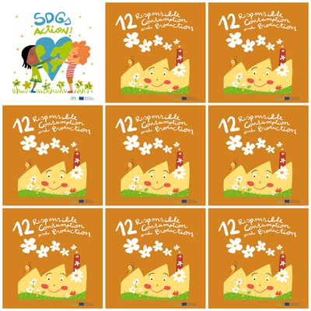

A plane spends 12.4 litres of fuel in one km.

In Catalonia, 262.000 tons of food are wasted every year.

About 17 trees are used to make a ton of paper. It must be taken into account that a tree provides oxygen for 3 people to breathe a day.

Every Catalan is responsible for 35 kg of food ending up in the trash.

**12. Responsible Consumption and Production**

**1.** .How many litres of fuel does a plane spend in one km?

**2.** How many tons of food are wasted every year in Catalonia?

**3.** How many trees are needed to make 1 ton of paper?

**4.** How much food is spent in every catalan?

**6.** How many flours are there?

**5.** What animal is in the logo?