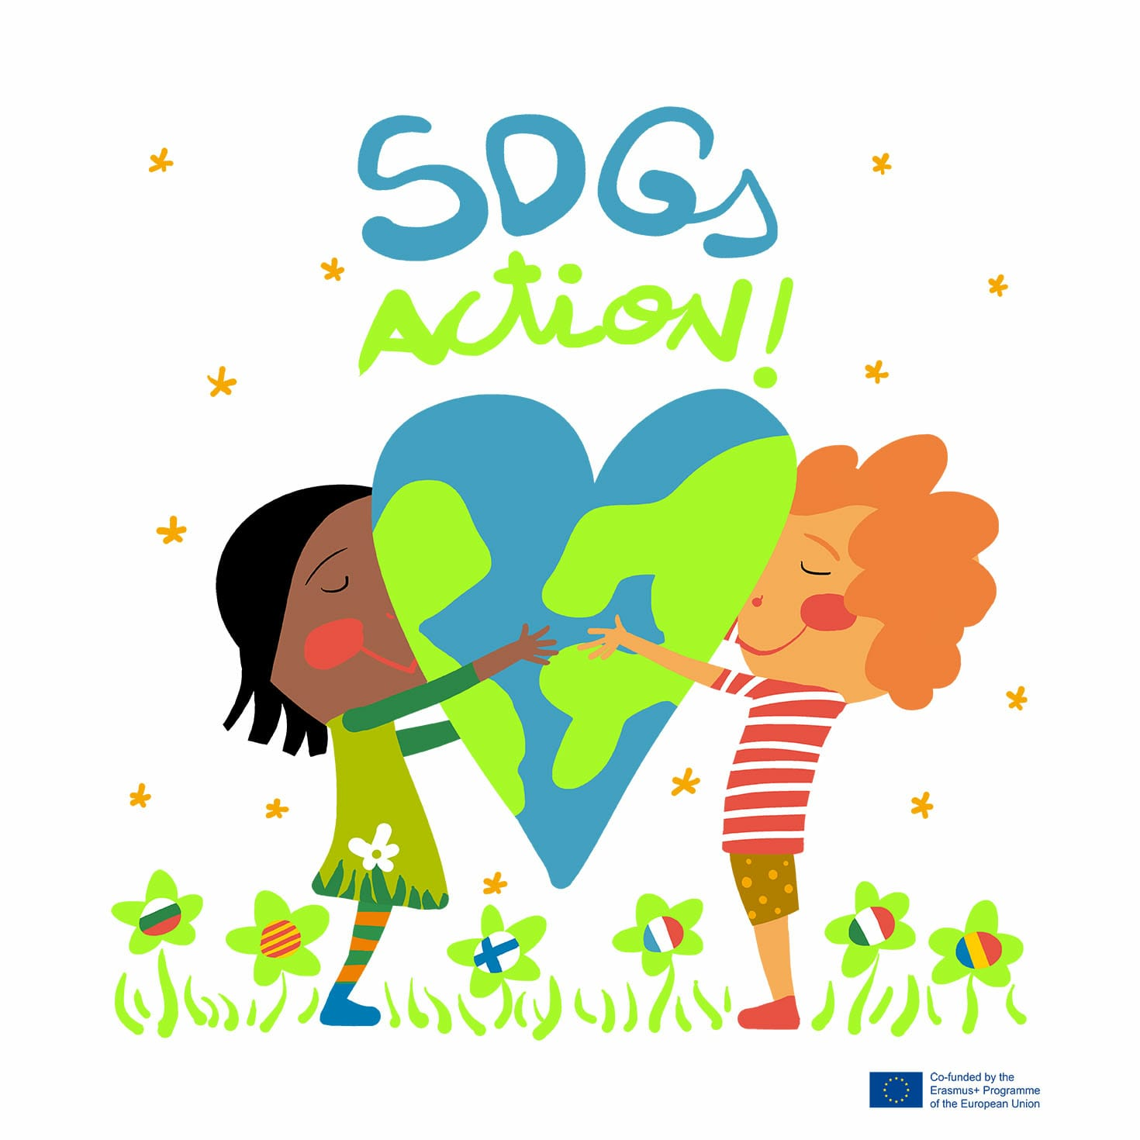
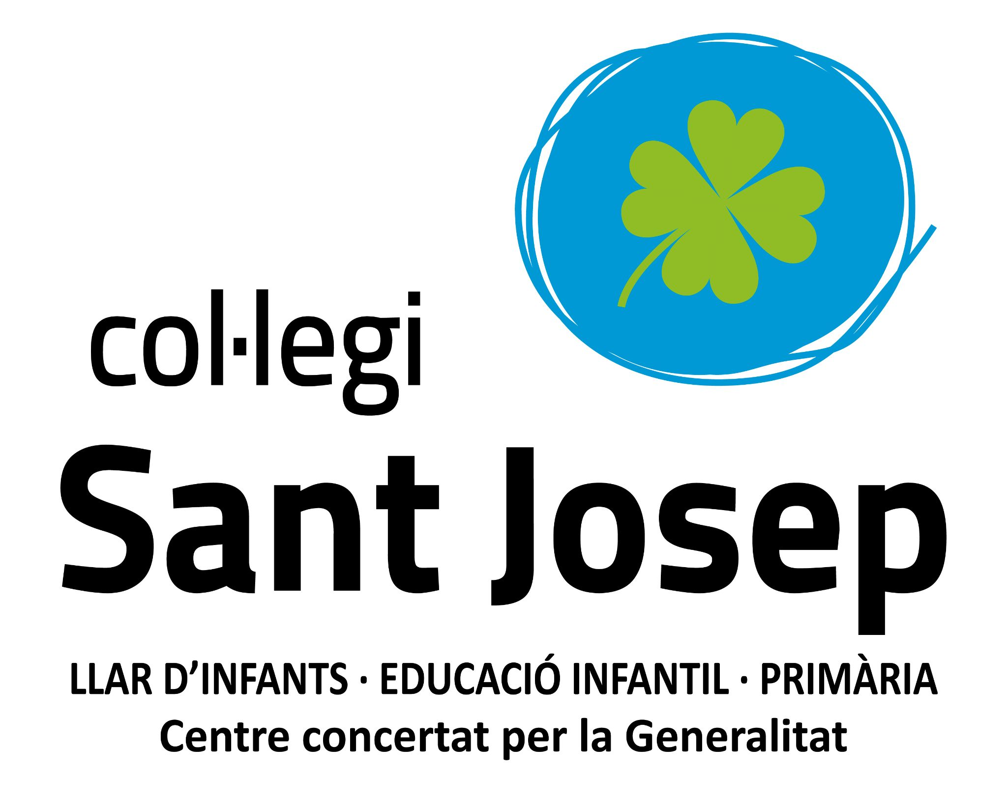
VIRTUAL MOBILITY CATALONIA
“LAUNCHING THE PROJECT”
19th - 21st May 2021

Goals:
- Spread the final results of the project
- Apply the knowledge gained during the project about SDGs throughout STEAM
- Share Scratch games made during the project and play other interactive games related to SDGs
- Interact among partner countries working cooperatively

Wednesday 19th May 2021

9:15 - 9:30 : Warm welcome
9:30 - 9:45 : Presenting our project Scratch games: Bulgaria, Catalonia, France
( 1 x country)
10:00 - 11:00: Makey Makey workshop: SDGs in a pizza box! ( See workshop description file)
T1: Cat- Bul
T2: Cat- Fin
T3: Cat- Fr
T4: Cat- It
T5: Cat- Rm

11:00 - 11:15: Break

11:15 - 11:30: Makey makey workshop: SDGs in a pizza box!

11:30 - 11: 50: SDGs Action! sculpture pair countries. ( See workshop description file)

Team 1: Romania -Italy
Team 2: Bulgaria - Finland
Team 3: Catalonia - France

11:50 - 12:00 : SDGs Action! Tick Tock

- - - - - - - - - - - - - - - - - - - - - - - - - - - - - - - - - - - - - - - - - - - -

15:30 - 16:30 : Jennifer Williams online meeting
- Introduction
- Each country tells her about a relevant activity of the project
- She asks questions about the project

VIRTUAL MOBILITY CATALONIA
“LAUNCHING THE PROJECT”
19-21st May 2021

Goal: spreading the final results of the project

Thursday 20th May 2021

9:15 - 9:30 : Warm up games: Catalonia - Bulgaria - France ( 5’ per country)

9:30 - 9:45 : Presenting our project Scratch games: Italy - Romania - Finland
( 1 x country)

9:45 - 10:00: Teachers escape room

10:00 - 10:15: Break

10:15 - 11:50: SDGs Action! sculpture pair countries ( See workshop description file)

Team 1: Romania -Italy
Team 2: Bulgaria - Finland
Team 3: Catalonia - France

11:50 - 12:00 : SDGs Action! Tick Tock

VIRTUAL MOBILITY CATALONIA
“LAUNCHING THE PROJECT”
19-21st May 2021

Goal: spreading the final results of the project

Friday 21st May 2021

9:15 - 9:30 : Warm up games: Italy - Romania - Finland ( 5’ per country)

9:30 - 9:45 : Presentation Makey Makey games

9:45 - 10:00: SDG Pass the word game

10:00 - 10:15: Break

10:15 - 10:30: Present SDGs Action! sculptures
Team 1: Romania -Italy
Team 2: Bulgaria - Finland
Team 3: Catalonia - France

10:30 - 11:30 : SDGs Action! Cultural show . 10’ per country

11:30 - 11: 40: Assessment

11: 40 - 11: 45: SDGs Action! Tick Tock

11:45 - 12:00 : certificates, gifts and goodbye ceremony

