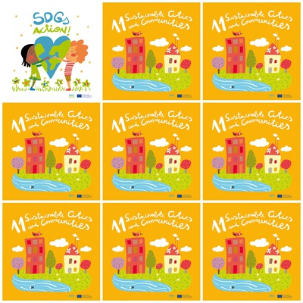

Help your local community, Preferring local products: Supporting local businesses: it keeps people employed and money into your community

cultural heritage

Take care of public spaces, watering greenery, planting trees, organizing a cleanup, etc.

Use bike, take public transport or walk and Save the car trips for when you’ve got a big group.

Support leaders in your local community and support projects in slums, building houses, fixing existing ones, setting up public or green spaces.

**11. Sustainable cities and Communities**

1. How can you move in a sustainable way?

2. How many trees are there in the Goal 11 logo?

3. How can we help improve public spaces?

4. How can you contribute volunteering in slums?

5. Who is important to support during elections?

6. When is it better to use the car?