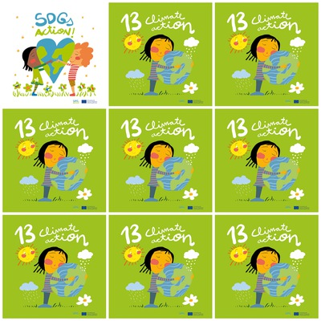

Our lungs are dangerously affected by the polluted air.

During Covid-19 pollution decreased.

Climate change is now affecting all the countries of the world.

Melting poles, droughts, ozone layer, weather disasters and animals in danger of extinction, are effects of the climate change.

**13. Climate Action**

1. Which part of our body is affected by the polluted  air?

2. When did pollution decrease?

3. Is the Climate change  affecting only some countries?

4. Say 3 effects of Climate Change.

5. Is the girl's sweater striped or spotted?

6. What 3 weather elements can you see in the logo?