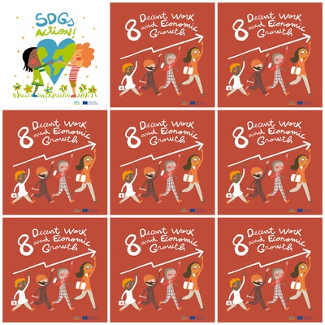w

Access to banking, insurance and financial services for all.

Trade support for developing countries.

Sustainable Economic Growth.

Support job creation and growing enterprises.

**8. Decent Work and Economic Growth**

1. What do we have to have access to?

2. What support is needed for developing countries?

**3.** What does Economic Grouth have to be?

**???**

5. What is the colour of the shoes of the last person in the column in the logo?

4. What needs to be supported?

6. What is the colour of the pants of the second person in the column in the logo?