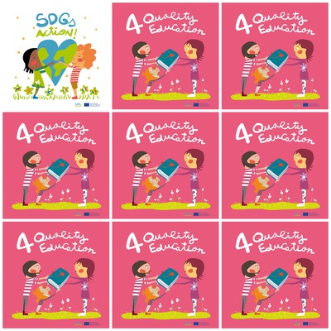

**In war zones 50% children do not go to school**

**60 millions adolescents are out of school in the world.**

**Africa is the continent where there are the most students out of school.**

**In 2030, girls and boys will access schools in the same way.**

**4. Quality Education**

**1. Which percentage of children do not go to school in war zone ?**

**2. How many adolescents are out of school?**

**3. In which continent are there the most out-of-school children ?**

**4. When will the differences in access to school between boys and girls be eliminated ?**

**5. How characters are there on the picture ?**

**6. What do the characters share ?**