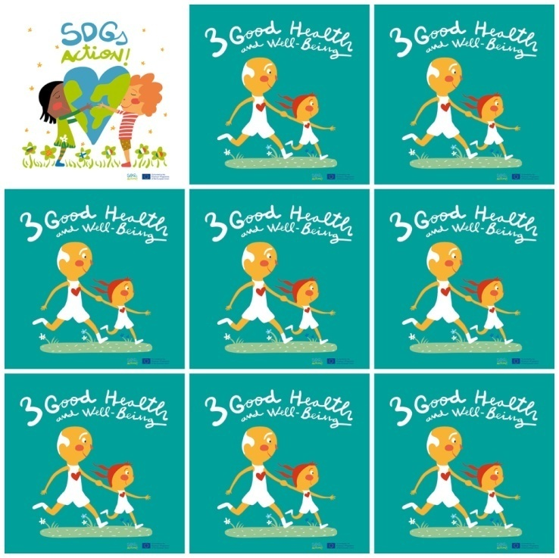

Since 2000 measles vaccines have averted nearly 15.6 million deaths.

Maternal mortality has fallen by 37% since 2000.

Tuberculosis remains the leading cause of death among people living with HIV.

A life without health is like a river without water.

**3. Good Health and well-Being**

**1.** How many people have been saved by the measles vaccine?

**2.** What type of  mortality has fallen 37%?

**3.** What illness is the leading cause of mortality among people with HIV?

**4.** How can you compare health with life?

**5.** What   is  the name  of SDG 3?

**6.** What are the kids holding in the logo?