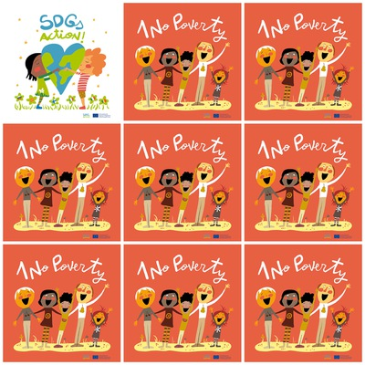

One of the quickest and most obvious ways to help the world's poor is to donate to charity.

India is one of the poorest countries in the world.

**Females, new-borns and old people are said to be the poorest of the poor.**

**Half of the world’s poor live in just 5 countries:** **India, Nigeria, Democratic Republic of Congo, Ethiopia, and Bangladesh.**

1. **No Poverty**

**1. What is the quickest way to help the world’s poor?**

**2. Which country is the poorest one?**

**3. Who are the poorest of the poor?**

**4. In which 5 countries do the world’s poor live in?**

**5**. **How many people can you see in the logo?**

**6. How many people raised their hands in the logo?**